**End of Semester Status Report**

**Statement of last Month’s Goals:**

* Present a summary of product needs, specifications, and functions to sponsor, as well as five proposed and one final project design in the Conceptual Design Review
* Generate a product architecture report detailing modularity in the design, interactions of different functional clusters, and presenting visuals of the product layout and a CAD model of the chosen design
* Present a refined design to the sponsor in the Preliminary Design Review
* Determine desired motor to drive the weight
* Create a project budget and source parts
* Determine a project timeline for next semester

**Progress:**

Most of the tasks were completed. We are still in the process of determining the desired motor to put into the shaker. This task may take some time at the beginning of the next semester while we are in the process of prototyping. The strategy for resolution of this problem is to run motors through Simulink simulations and find the perfect motor to run a bridge shaker of our shaker’s size and weight.

**Challenges:**

Some challenges posed for the linear weight design will be the sleeve that will house it and the method of lubrication for the moving parts to keep them undamaged. We have looked at guide rails to possible use in conjunction with the sleeve to minimize wear. The other challenge is with regards to choosing the right motor, as of right now we have the general specifications for the motor narrowed down but are still looking for one that can be bought at a price range acceptable to Professor Downey. The final challenge is creating a suitable frame for the shaker, we are looking at mostly using aluminum, which will be welded to ensure parts will not shake loose.

**Goals:**

The TBD’s to be resolved are the motor which will be used, the method of housing and friction reduction for the weight, and the bearings which will be used for the shaft. The motor will be purchased with the aid of Professor Downey and the specifications for it which the Simulink model was used for. The friction reduction and weight housing methods will also be discussed with Professor Downey, but a guide rail system looks viable. The bearings for the shaft are less important at this point but will also be narrowed down when we are closer to construction. We will also be testing the accelerometers on the bridge before we use them on the bridge in conjunction with the shaker.

**Purchasing:**

Due to the TBDs, the motor is not ready to be purchased until accelerometer testing is performed and the required rpm of the motor is determined. The attached budget has an estimated price of 400 USD for the motor based on past research as it is still TBD. Some items are ready to be purchased, including all the electronics, sensors, and housing material. These purchases will be handled by the team through the responsible students in Dr. Downey’s lab.

**Final Concept:**

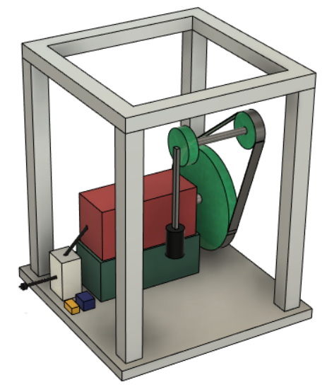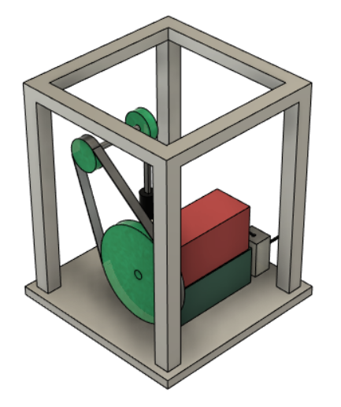

Figure 1. Side views of final concept.

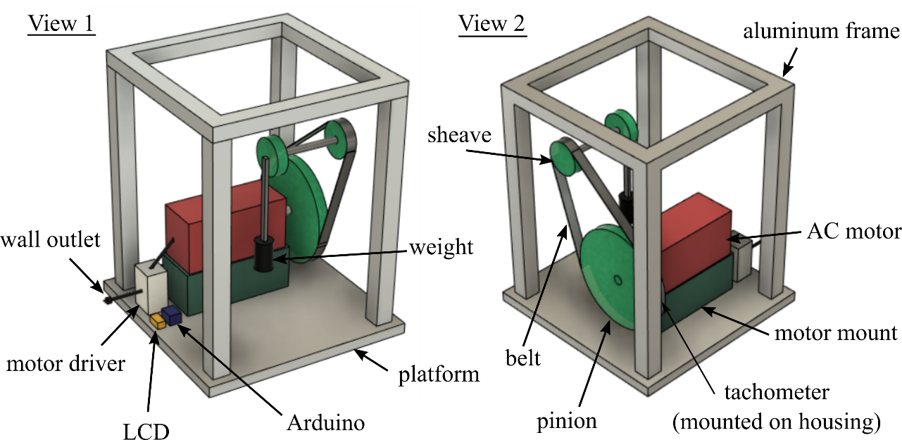

Figure 2. Labeled views of the selected concept

**Proposed Bill of Materials**

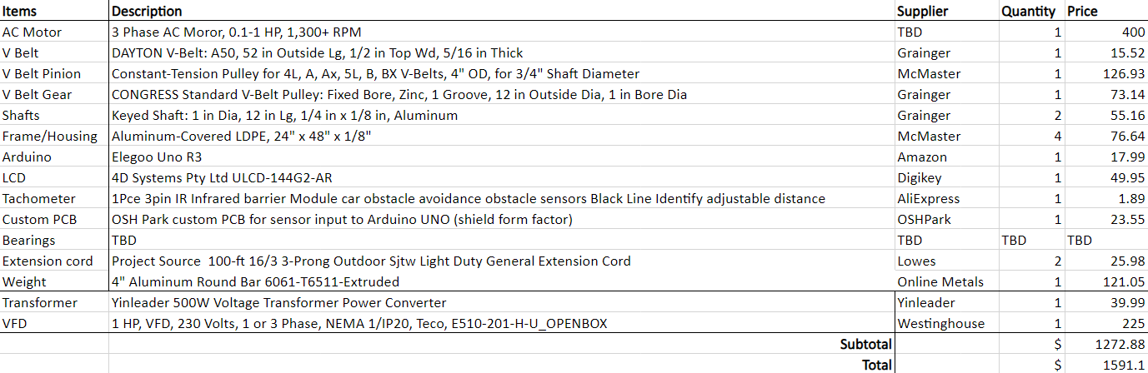

**Project Scope and Budget Agreement**

**1. Scope of the project defined:**

The student design team will construct a prototype of a bridge shaker that tests vibration data, operates at different frequencies, is safe to operate, and leaves the bridge undamaged. The prototype will feature a shaking weight that will transfer energy to the bridge with user control of a motor driver and feedback supplied by in-house sensors.

**2. Deliverables:**

a. The prototype will be turned over to the sponsor by April 25, 2023

b. The associated GitHub will be fully documented and publicized by April 25, 2023 containing: STL files, Arduino code, operation instructions, build designs/instructions, models, bill of materials

**3. Agreed project budget amount**

The bill of materials determined by the design team must not exceed $1591.10. This is the total calculated project cost with a 25% increase for contingencies and shipping. Once agreed upon, budget changes must be taken to Dr. Downey directly and approved by Dr. Downey before implementation.

**4. Statement of who is responsible for purchasing/acquisition**

Purchasing will be a joint effort between the project sponsor, Dr. Downey, and the design team. All components will be brought to Dr. Downey’s attention before purchasing. The design team oversees sourcing parts and components that suit the needs of the project sponsor and will find the most reasonable items for purchase.

**5. Statement of who is responsible for machining/fabrication/assembly**

The design team oversees machining and fabrication whether it be in-house or sourcing a machinist to complete the work. All other assembly will be completed by the design team at or before the specified deadlines. If there is an issue with any of the above, the design team will notify Dr. Downey and arrangements will be made to solve the issue in a timely manner.

*Due to the rigid and short timeline associated with this project, there will be no substantial changes to the scope of the concept or deliverables once both parties (project sponsor and student design team) agree on the above items.*

Sponsor Signature: ______________________________________ Date: ____________

Team Member 1: _______________________________________ Date: ____________

Team Member 2: _______________________________________ Date: ____________

Team Member 3: _______________________________________ Date: ____________

Team Member 4: _______________________________________ Date: ____________